Internal

All information contained in this document is property of WHATSAPP Group, Inc. No license, expressed or implied, under any patent, copyright or trade secret right is granted or implied by the conveyance of this document. No part of this document may be reproduced, transmitted, transcribed, stored in a retrieval system, translated into any language or computer language, in any form or by any means, electronic, mechanical, magnetic, optical, chemical, manual, or otherwise without the prior written permission of WHATSAPP Group, Inc. (See Standard Document Security, 320190-000 for details.)
Copyright © WHATSAPP Group, Inc. All rights reserved.

Security Level |  | 2
WhatsApp v2.2 Sprint 3 Test Report
Document Number: | 365-095-25183
Revision: | x.1
Author(s): | xyz
Revision Date: | 1/2/2013
WHATSAPP Group, Inc..
101 Tournament Drive
Horsham, PA 19044

Revision History
Rev | Description | Author(s) | Date
x.1 | Initial version | Ashok Sharma | 10/31/2013
x.1 | Updated the test case execution data | Ashok Sharma | 2/1/2013
Table of Contents
Section Title Page Number
1. Introduction 4
1.1. Abbreviations and Acronyms 4
1.2. Applicable Documents 5
2. Test 5
2.1. Test Setup 5
3. V1.3.03.06 Build Summary 6
4. Test Summary 6
4.1.1. VMS1100 Cycle 6
4.1.2. IPC1100 Cycle 8
5. Blocked Test case details 9
6. Failed Test case details 9
MotoPLYR hangs on execution through Play key 9
MotoPLYR hangs on 85% execution. 9

List of Figures
Section Title Page Number
Figure 1: Test Setup 6
Figure 2 Result Summary 7
Figure 3: Test Summary 9

List of Tables
Section Title Page Number
Table 1: Acronyms and Definitions 5
Table 2: Applicable Documents 5

Introduction
This document provides the test report information WhatsApp Client 2.2.03.00 that operates on the KA platform to provide a diagnostic tool for the VMS product family
The MotoPLYR system provides diagnostic and test operations for the KA platform product family. These low level tests allow validation of the hardware and hardware abstraction software of the KA platform products, the subscriber’s home network and the service provider’s access network when fielded with minimal external test fixtures. The MotoPLYR system is extensible to include higher level diagnostics to support new features and services provided by operators.
This MotoPLYR release supports for the following models:
- Smasung galaxy model
- Motorola xoom model

Abbreviations and Acronyms

Acronym | Description
CRC | Cyclic Redundancy Code
DRAM | Dynamic Random Access Memory
FR | Feature Requirement
FQDN | Fully Qualified Domain Name
FTP | File Transfer Protocol
GUID | Globally Unique Identifier
HDD | Hard Disk Drive
HPNA | Home Phone line Networking Alliance
ICMP | Internet Control Message Protocol
IPTV | Internet Protocol Television
JRE | Java Runtime Environment
LAN | Local Area Network
MAC | Media Access Control
MP | MotoPLYR
MP-BL | MotoPLYR Boot Loader
MTFTP | Multicast Trivial File Transfer Protocol
MTU | Maximum Transport Unit
SPRB | Software Pedigree Review Board
PMR | Product Market Requirements
SFTP | Secure File Transfer Protocol
SHA-1 | Secure Hash Algorithm (version 1.0)
SMART | Self-Monitoring, Analysis, and Reporting Technology
STB | Set top box
TFTP | Trivial File Transfer Protocol
TLV | Tag Length Value
TR | Technical Requirement
UI | User Interface
UTF | Unicode Transformation Format
VIP | Video Internet Protocol
WAN | Wide Area Network
XML | extensible Markup Language
SI&T | System Integration and Testing
TBD | To be determine
Table 1: Acronyms and Definitions

Applicable Documents
Ref # | Document Location | Description/DCM #
HLD01 | High level design
LLD02 | Low Level Design
PFS01 | Software requirement specification
PFS02 | Business Requirement specifiction
PMR01 | UI document
UC01 | Test Plan
Table 2: Applicable Documents

Test

Test Setup
This release se has been tested using VMS1100 and IPC1100P1 boards with the below test setup.
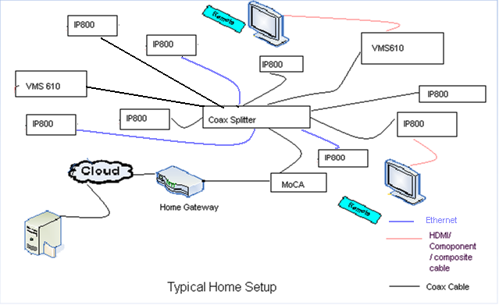
Figure 1: Test Setup

Note that only 2 VMS and 4 IPC STB were used as 8 IP STB was not available.

V1.3.03.06 Build Summary
SPRINT 3 DVT cycle was performed on KA1.2_Maint_Motoplyr r356270 SVN Branch.

Test Summary
The test summary for V2.3.03.00 is embedded in below spreadsheet.
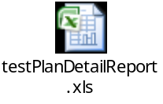

Motorola Cycle

Whatsapp Release V2.2.03.00- Samsung
Item | Items | Total Test Cases | Total Passed | Total Failed | Blocked | Not Applicable | Success Rate
1 | Code Download | 2 | 2 | 0 | 0 | 0 | 100.00%
2 | General Requirements | 8 | 6 | 2 | 0 | 0 | 75.00%
3 | HUM | 16 | 16 | 0 | 0 | 0 | 100.00%
4 | LAN | 17 | 17 | 0 | 0 | 0 | 100.00%
5 | Logging | 5 | 5 | 0 | 0 | 0 | 100.00%
6 | Secure OS | 1 | 1 | 0 | 0 | 0 | 100.00%
7 | Factory configuration | 1 | 1 | 0 | 0 | 0 | 100.00%
8 | HDD | 4 | 4 | 0 | 0 | 0 | 100.00%
9 | HDMI | 3 | 3 | 0 | 0 | 0 | 100.00%
10 | DRAM | 1 | 1 | 0 | 0 | 0 | 100.00%
11 | LED | 6 | 6 | 0 | 0 | 0 | 100.00%
12 | Tuner | 21 | 21 | 0 | 0 | 0 | 100.00%
13 | System Information | 4 | 4 | 0 | 0 | 0 | 100.00%
14 | User Interface | 11 | 10 | 1 | 0 | 0 | 90.90%
15 | Clean and screen | 8 | 7 | 1 | 0 | 9 | 87.50%

Total Test Cases: | 108
Total Passed: | 104
Total Failed: | 4
Blocked | 0
Not Applicable | 0
% Total Attempted TCs | 97.84%
%Build Rel V1.3.03.06 Success | 97.84%
Test Set up
Date | 2-Feb-13
SVN Build version | 356270

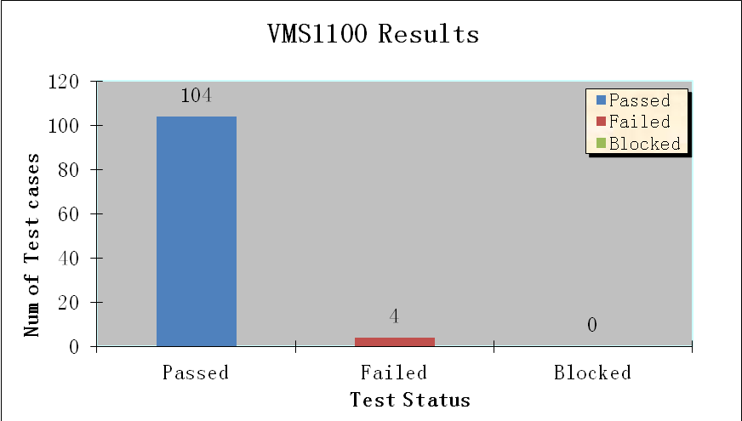
Figure 2 Result Summary

Samsung Cycle

KA MototPLYR Release V2.2.03.00- IPC1100
Item | Items | Total Test Cases | Total Passed | Total Failed | Blocked | Not Applicable | Success Rate
1 | Code Download | 2 | 2 | 0 | 0 | 0 | 100.00%
2 | General Requirements | 8 | 8 | 0 | 0 | 0 | 100.00%
3 | HUM | 15 | 15 | 0 | 0 | 0 | 100.00%
4 | LAN | 17 | 17 | 0 | 0 | 0 | 100.00%
5 | Logging | 5 | 5 | 0 | 0 | 0 | 100.00%
6 | Secure OS | 1 | 1 | 0 | 0 | 0 | 100.00%
7 | Factory configuration | 1 | 1 | 0 | 0 | 0 | 100.00%
9 | HDMI | 3 | 3 | 0 | 0 | 0 | 100.00%
10 | DRAM | 1 | 1 | 0 | 0 | 0 | 100.00%
11 | LED | 6 | 6 | 0 | 0 | 0 | 100.00%
13 | System Information | 4 | 4 | 0 | 0 | 0 | 100.00%
14 | User Interface | 11 | 10 | 1 | 0 | 0 | 90.90%
15 | Clean and screen | 8 | 7 | 1 | 0 | 9 | 87.50%

Total Test Cases: | 82
Total Passed: | 80
Total Failed: | 2
Blocked | 0
Not Applicable | 0
% Total Attempted TCs | 97.62%
%Build Rel V1.3.03.06 Success | 97.62%
Test Set up
Date | 2-Feb-13
SVN Build version | 356270

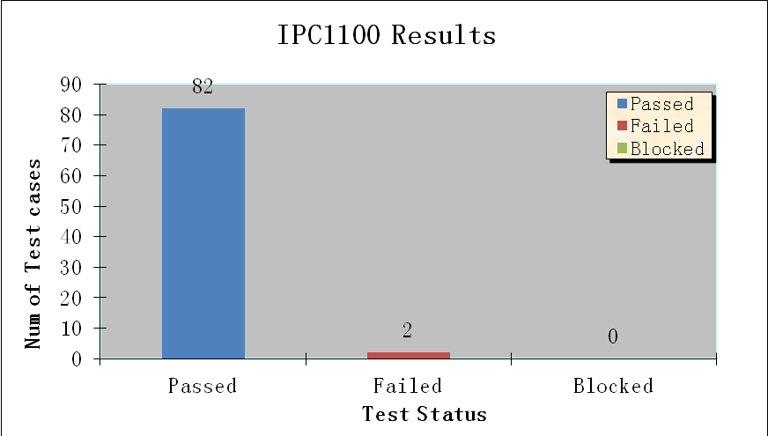
Figure 3: Test Summary

Blocked Test case details
None

Failed Test case details
S.No | Test case | JIRA | JIRA | Severity | Occurance | Comments
1 | MotoPLYR KreaTV.C&S.I/O:001-001 | OKVIPMP3G-13151 | AV mute is not handled for remote control protocol | Minor | 20/20 | Fix will be available in the next relese.
2 | MotoPLYR KreaTV.User Interface :001-011 | OKVIPMP3G-13153 | MotoPLYR hangs on execution through Play key | Major | 20/20 | Fix will be available in the next relese.
3 | MotoPLYR KreaTV.General reqs Interface :001-002 | OKVIPMP3G-13156 | MotoPLYR reboots on launch of Automated test UI | Minor | Observed once | Issue not reproducible, DVT team is tracking this issue
4 | MotoPLYR KreaTV.General reqs Interface :001-012 | OKVIPMP3G-13157 | MotoPLYR hangs on 85% execution. | Minor | Observed once | Issue not reproducible, DVT team is tracking this issue

